HW6_吳明軒

RE6124019

2023-12-04

# 9.6 Lab: Support Vector Machines

## 9.6.1 Support Vector Classifier

set.seed(1)  
x <- matrix(rnorm(20 * 2), ncol = 2)  
y <- c(rep(-1, 10), rep(1, 10))   
x[y == 1,] <- x[y == 1,] + 1  
plot(x, col=(3 - y))

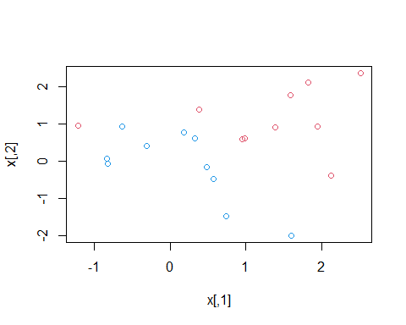

dat <- data.frame(x = x, y = as.factor(y))  
library(e1071)  
svmfit <- svm(y ~ ., data = dat, kernel = "linear",   
 cost = 10, scale = FALSE)   
  
plot(svmfit, dat)

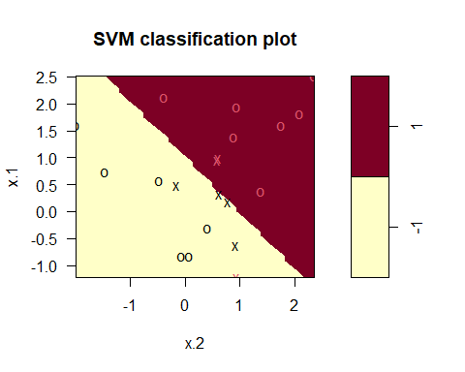

svmfit$index

## [1] 1 2 5 7 14 16 17

summary(svmfit)

##   
## Call:  
## svm(formula = y ~ ., data = dat, kernel = "linear", cost = 10, scale = FALSE)  
##   
##   
## Parameters:  
## SVM-Type: C-classification   
## SVM-Kernel: linear   
## cost: 10   
##   
## Number of Support Vectors: 7  
##   
## ( 4 3 )  
##   
##   
## Number of Classes: 2   
##   
## Levels:   
## -1 1

svmfit <- svm(y ~ ., data = dat, kernel = "linear",   
 cost = .01, scale = FALSE)  
plot(svmfit, dat)

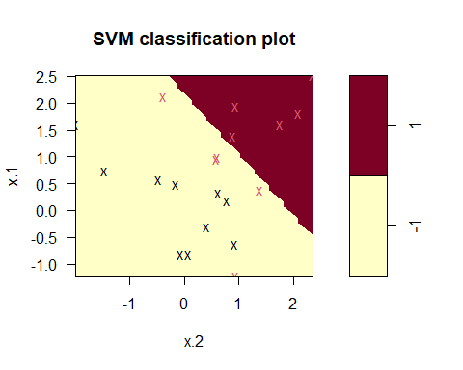

svmfit$index

## [1] 1 2 3 4 5 6 7 8 9 10 11 12 13 14 15 16 17 18 19 20

set.seed (1)  
tune.out <- tune(svm , y~., data = dat , kernel = "linear",  
 ranges = list(cost = c(0.001 , 0.01 , 0.1 , 1, 5, 10 , 100)))  
  
summary (tune.out)

##   
## Parameter tuning of 'svm':  
##   
## - sampling method: 10-fold cross validation   
##   
## - best parameters:  
## cost  
## 0.1  
##   
## - best performance: 0.05   
##   
## - Detailed performance results:  
## cost error dispersion  
## 1 1e-03 0.55 0.4377975  
## 2 1e-02 0.55 0.4377975  
## 3 1e-01 0.05 0.1581139  
## 4 1e+00 0.15 0.2415229  
## 5 5e+00 0.15 0.2415229  
## 6 1e+01 0.15 0.2415229  
## 7 1e+02 0.15 0.2415229

bestmod <- tune.out $ best.model  
summary (bestmod)

##   
## Call:  
## best.tune(METHOD = svm, train.x = y ~ ., data = dat, ranges = list(cost = c(0.001,   
## 0.01, 0.1, 1, 5, 10, 100)), kernel = "linear")  
##   
##   
## Parameters:  
## SVM-Type: C-classification   
## SVM-Kernel: linear   
## cost: 0.1   
##   
## Number of Support Vectors: 16  
##   
## ( 8 8 )  
##   
##   
## Number of Classes: 2   
##   
## Levels:   
## -1 1

xtest <- matrix(rnorm(20 * 2), ncol = 2)  
ytest <- sample(c(-1, 1), 20, rep = TRUE)   
xtest[ytest == 1,] <- xtest[ytest == 1,] + 1  
testdat <- data.frame(x = xtest, y = as.factor(ytest))  
  
ypred <- predict(bestmod, testdat)  
table(predict = ypred, truth = testdat$y)

## truth  
## predict -1 1  
## -1 9 1  
## 1 2 8

svmfit <- svm(y ~ ., data = dat, kernel = "linear",   
 cost = .01, scale = FALSE)  
ypred <- predict(svmfit , testdat)  
table(predict = ypred , truth = testdat$y)

## truth  
## predict -1 1  
## -1 11 6  
## 1 0 3

x[y == 1, ] <- x[y == 1, ] + 0.5  
plot(x, col = (y + 5) / 2, pch = 19)

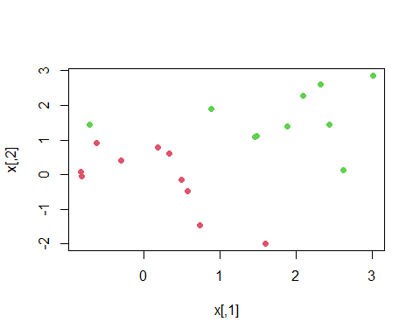

dat <- data.frame(x = x, y = as.factor(y))  
svmfit <- svm(y ~ ., data = dat, kernel = "linear", cost = 1e5)  
summary(svmfit)

##   
## Call:  
## svm(formula = y ~ ., data = dat, kernel = "linear", cost = 1e+05)  
##   
##   
## Parameters:  
## SVM-Type: C-classification   
## SVM-Kernel: linear   
## cost: 1e+05   
##   
## Number of Support Vectors: 3  
##   
## ( 1 2 )  
##   
##   
## Number of Classes: 2   
##   
## Levels:   
## -1 1

plot(svmfit, dat)

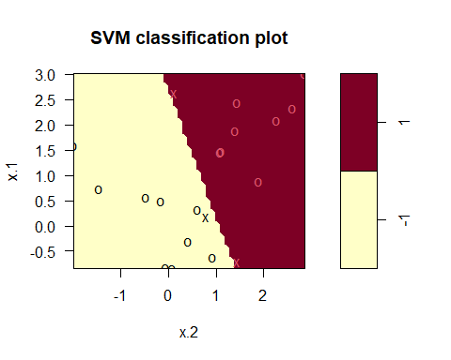

svmfit <- svm(y ~ ., data = dat, kernel = "linear", cost = 1)  
summary(svmfit)

##   
## Call:  
## svm(formula = y ~ ., data = dat, kernel = "linear", cost = 1)  
##   
##   
## Parameters:  
## SVM-Type: C-classification   
## SVM-Kernel: linear   
## cost: 1   
##   
## Number of Support Vectors: 7  
##   
## ( 4 3 )  
##   
##   
## Number of Classes: 2   
##   
## Levels:   
## -1 1

plot(svmfit, dat)

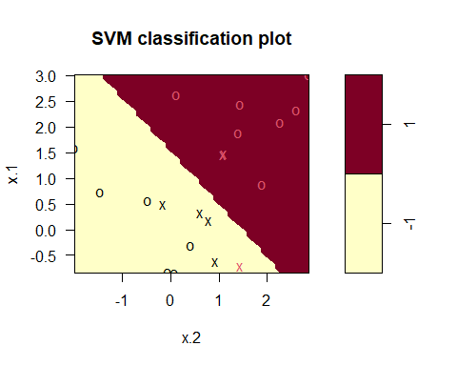 ## 9.6.2 Support Vector Machine

set.seed(1)  
x <- matrix(rnorm(200 * 2), ncol = 2)  
x[1:100,] <- x[1:100,] + 2   
x[101:150,] <- x[101:150,] - 2  
y <- c(rep(1,150), rep(2,50))  
dat <- data.frame(x = x, y = as.factor(y))  
  
plot(x, col = y)

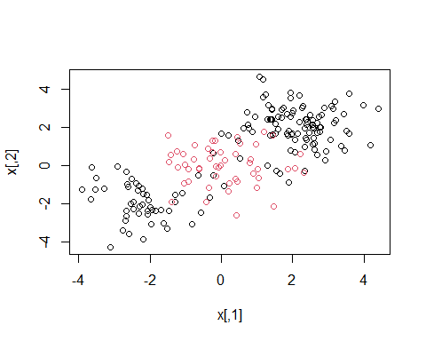

train <- sample(200, 100)   
svmfit <- svm(y ~ ., data = dat[train,], kernel = "radial",  
 gamma = 1, cost = 1)  
plot(svmfit, dat[train,])

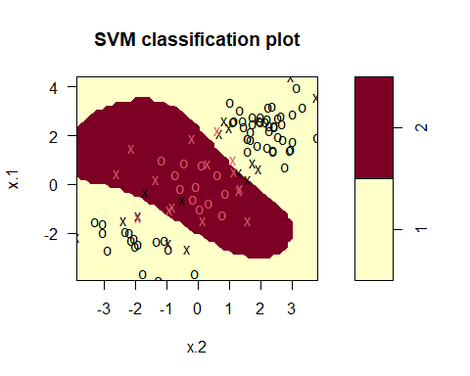

summary(svmfit)

##   
## Call:  
## svm(formula = y ~ ., data = dat[train, ], kernel = "radial", gamma = 1,   
## cost = 1)  
##   
##   
## Parameters:  
## SVM-Type: C-classification   
## SVM-Kernel: radial   
## cost: 1   
##   
## Number of Support Vectors: 31  
##   
## ( 16 15 )  
##   
##   
## Number of Classes: 2   
##   
## Levels:   
## 1 2

svmfit <- svm(y ~ ., data = dat[train,], kernel = "radial",  
 gamma = 1, cost = 1e5)  
plot(svmfit, dat[train,])

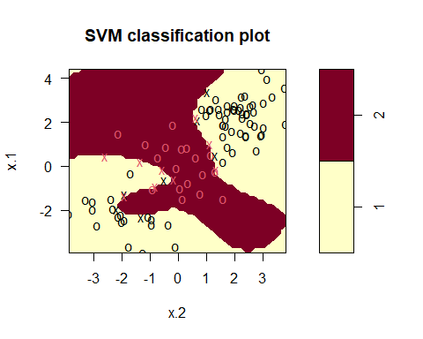

set.seed(1)  
tune.out <- tune(svm, y ~ ., data = dat[train,],   
 kernel = "radial",   
 ranges = list(  
 cost = c(0.1, 1, 10, 100, 1000),  
 gamma = c(0.5, 1, 2, 3, 4)  
 ))  
summary(tune.out)

##   
## Parameter tuning of 'svm':  
##   
## - sampling method: 10-fold cross validation   
##   
## - best parameters:  
## cost gamma  
## 1 0.5  
##   
## - best performance: 0.07   
##   
## - Detailed performance results:  
## cost gamma error dispersion  
## 1 1e-01 0.5 0.26 0.15776213  
## 2 1e+00 0.5 0.07 0.08232726  
## 3 1e+01 0.5 0.07 0.08232726  
## 4 1e+02 0.5 0.14 0.15055453  
## 5 1e+03 0.5 0.11 0.07378648  
## 6 1e-01 1.0 0.22 0.16193277  
## 7 1e+00 1.0 0.07 0.08232726  
## 8 1e+01 1.0 0.09 0.07378648  
## 9 1e+02 1.0 0.12 0.12292726  
## 10 1e+03 1.0 0.11 0.11005049  
## 11 1e-01 2.0 0.27 0.15670212  
## 12 1e+00 2.0 0.07 0.08232726  
## 13 1e+01 2.0 0.11 0.07378648  
## 14 1e+02 2.0 0.12 0.13165612  
## 15 1e+03 2.0 0.16 0.13498971  
## 16 1e-01 3.0 0.27 0.15670212  
## 17 1e+00 3.0 0.07 0.08232726  
## 18 1e+01 3.0 0.08 0.07888106  
## 19 1e+02 3.0 0.13 0.14181365  
## 20 1e+03 3.0 0.15 0.13540064  
## 21 1e-01 4.0 0.27 0.15670212  
## 22 1e+00 4.0 0.07 0.08232726  
## 23 1e+01 4.0 0.09 0.07378648  
## 24 1e+02 4.0 0.13 0.14181365  
## 25 1e+03 4.0 0.15 0.13540064

table(  
 true = dat[-train, "y"],  
 pred = predict(  
 tune.out$best.model, newdata = dat[-train,]   
 )  
)

## pred  
## true 1 2  
## 1 67 10  
## 2 2 21

## 9.6.3 ROC Curves

library(ROCR)

## Warning: package 'ROCR' was built under R version 4.3.2

rocplot <- function(pred, truth, ...) {  
 predob <- prediction(pred, truth)  
 perf <- performance(predob, "tpr", "fpr")  
 plot(perf, ...)  
}  
  
svmfit.opt <- svm(y ~ ., data = dat[train, ], kernel = "radial", gamma = 2, cost = 1, decision.values = TRUE)  
fitted <- attributes(predict(svmfit.opt, dat[train, ], decision.values = TRUE))$decision.values  
  
par(mfrow = c(1, 2))  
rocplot(-fitted, dat[train, "y"], main = "Training Data")  
  
svmfit.flex <- svm(y ~ ., data = dat[train, ], kernel = "radial", gamma = 50, cost = 1, decision.values = TRUE)  
fitted <- attributes(predict(svmfit.flex, dat[train, ], decision.values = TRUE))$decision.values  
rocplot(-fitted, dat[train, "y"], add = TRUE, col = "red")  
  
fitted <- attributes(predict(svmfit.opt, dat[-train, ], decision.values = TRUE))$decision.values  
  
rocplot(-fitted, dat[-train, "y"], main = "Test Data")  
fitted <- attributes(predict(svmfit.flex, dat[-train, ], decision.values = TRUE))$decision.values  
rocplot(-fitted, dat[-train, "y"], add = TRUE, col = "red")

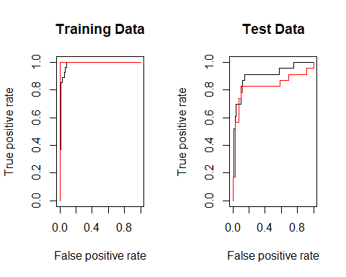 ## 9.6.4 SVM with Multiple Classes

set.seed(1)  
x <- rbind(x, matrix(rnorm(50 * 2), ncol = 2))  
y <- c(y, rep(0, 50))  
x[y == 0, 2] <- x[y == 0, 2] + 2  
dat <- data.frame(x = x, y = as.factor(y))  
par(mfrow = c(1, 1))  
plot(x, col = (y + 1))

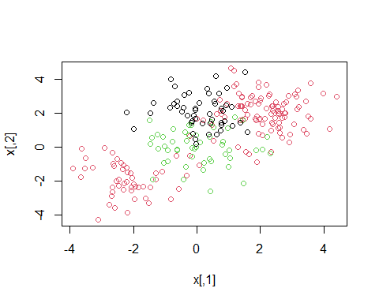

svmfit <- svm(y ~ ., data = dat, kernel = "radial", cost = 10, gamma = 1)  
plot(svmfit, dat)

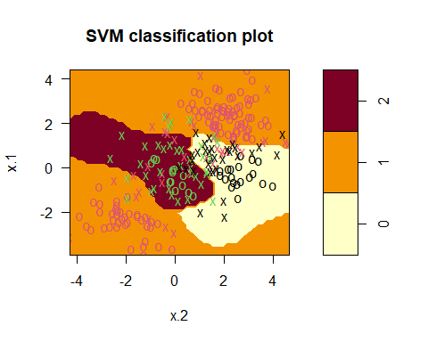 ## 9.6.5 Application to Gene Expression Data

library(ISLR2)

## Warning: package 'ISLR2' was built under R version 4.3.2

names(Khan)

## [1] "xtrain" "xtest" "ytrain" "ytest"

dim(Khan$xtrain)

## [1] 63 2308

dim(Khan$xtest)

## [1] 20 2308

length(Khan$ytrain)

## [1] 63

length(Khan$ytest)

## [1] 20

table(Khan$ytrain)

##   
## 1 2 3 4   
## 8 23 12 20

table(Khan$ytest)

##   
## 1 2 3 4   
## 3 6 6 5

dat <- data.frame(  
 x = Khan$xtrain,  
 y = as.factor(Khan$ytrain)  
)  
  
out <- svm(y ~ ., data = dat, kernel = "linear", cost = 10)  
  
summary(out)

##   
## Call:  
## svm(formula = y ~ ., data = dat, kernel = "linear", cost = 10)  
##   
##   
## Parameters:  
## SVM-Type: C-classification   
## SVM-Kernel: linear   
## cost: 10   
##   
## Number of Support Vectors: 58  
##   
## ( 20 20 11 7 )  
##   
##   
## Number of Classes: 4   
##   
## Levels:   
## 1 2 3 4

table(out$fitted, dat$y)

##   
## 1 2 3 4  
## 1 8 0 0 0  
## 2 0 23 0 0  
## 3 0 0 12 0  
## 4 0 0 0 20

dat.te <- data.frame(  
 x = Khan$xtest,  
 y = as.factor(Khan$ytest)  
)  
  
pred.te <- predict(out, newdata = dat.te)  
table(pred.te, dat.te$y)

##   
## pred.te 1 2 3 4  
## 1 3 0 0 0  
## 2 0 6 2 0  
## 3 0 0 4 0  
## 4 0 0 0 5